<Short name of Epic>
- The concept of an Epic here is an adaptation of an Epic within the Scale Agile Framework (SAFe).
- An Epic refers to a perceived large scientific software need/idea that will advance aspects of ISIS. Consider "large" to mean a need with an initial estimate requiring the effort of at least one person for a quarter of a year or more (≥ 0.25 FTY) to complete all features in scope. As this document is gradually completed through conversations, reviews, and analyses, a revised work estimate may reveal that it is small enough to be dealt with by other means.
- To start an Epic, the minimum required information is a Funnel Entry Date, a title and an initial Epic Description. If this is completed by someone who is not a member of the scientific software group, then beforehand or upon completion notify your contact within the scientific software group or contact Janu (januka.wijesinghe-ekanayaka@stfc.ac.uk) or Anders (anders.markvardsen@stfc.ac.uk) to help your idea get shared and get early feedback.
- Epic Owner: A person who is best positioned to engage with providing requirements/inputs and assist with the review and analysis of this Epic. If the Epic progresses to implementation, the Epic Owner is expected to help with the testing, validation, and evolving understanding of the Epic.
- SAFe defines two main types of Epics:
  - Business Epic: Provides new functionality to external users and ISIS staff. The Epic Owner is expected to represent the users who will benefit from the Epic.
  - Enabler Epic: As the name suggests, it enables future Business Epics. These are the Epics needed to enable or improve the ease with which the development team can create future Business Epics. An enabler Epic Owner is likely to be a software engineer or software scientist.

Funnel Entry Date:  (Enter the date in which you started to fill this document)  <ans> | Epic Owner:  (Who is the key individual driving the Epic? It is usually the person who is providing the requirements and/or the person who can represent the relevant users)  <ans> |  | Key Stakeholders:  (Who are other relevant stakeholders, they may be scientists, user groups and project/product managers)  <ans>
Epic Description:
(Suggest initiating the writing in the for, who format, with no requirement to strictly follow it. Optionally add more details using free text, pictures etc. If you are unsure if this is a business or enabler Epic, please specify why.)
For <users and/or groups of users>
who <do something, such as a certain type of experiment>
the <something scientific software solution/tool/framework/algorithm/service/other>
is a <short description of what it is>
that <provides this value>
unlike <competitor, current solution, or non-existing solution>
our solution <does something better>

Type of Epic: (Business or Enabler)
Optional: Is there a significant downside(s) if this problem is not solved?

Measurable ISIS Benefits:  (The measurable benefits that can be anticipated if this Epic hypothesis is proven to be true. These can be quantitative or qualitative.  Think about how ISIS as an organization can benefit from this. For example, continually searching for new ways to conduct experiments and improve the accuracy and efficiency of existing data processes. Such factors help maintain/further establish ISIS as a reputable organization that scientists globally would wish to use.)  <ans> |  | Leading Indicators:  (Metrics that can be checked during the implementation, which indicate if the development is on the right track or not. E.g. “The time it takes to run data reduction workflow X on dataset Y on Z hardware” and “The number of crash reports that contain sufficient information to reproduce the error”. Note for some Epics there may be no (easily) identifiable leading indicator, and therefore the first feedback opportunity is when the MVP is (nearly) complete.)  <ans>
Features in Scope:  (The full list of features that are needed to deliver this Epic, in addition to the scope covered by the MVP)  <ans>  Optionally, note things that are out of scope (e.g. to clarify where there might be assumptions)  <ans> |  | Features in the Minimum Viable Product (MVP)  (The minimum ‘experiment’ that can be done to demonstrate the required benefits. This needs to be true before we persevere to implement the full set of features in scope. The figure below taken from: Making sense of MVP - Crisp's Blog)  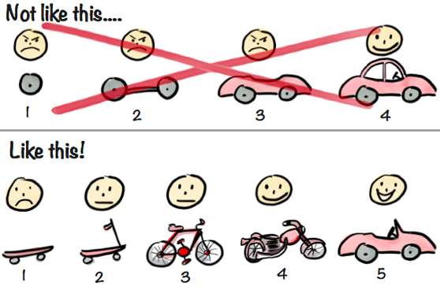
Nonfunctional Requirements (NFRs):
(Beyond the core functionality, nonfunctional requirements focus on areas such as performance, usability, maintainability, compatibility, scalability, logging, and data security. NFRs are persistent qualities and constraints typically revisited as part of the definition of done (DoD))
<ans>
Environmental Sustainability:
(Think about CPU usage, memory usage, new hardware, and energy consumption aspects. In addition to this, contemplate if the outcome of this Epic has wider benefits/negative implications for environmental sustainability, such as changes to instrument operations. If you need more guidance, please reach out to Sam (sam.tygier@stfc.ac.uk))
<ans>
External Commitments:
(Please list external commitments, such as the commissioning date of a new instrument or new technique to use on an existing instrument.)
<ans>
Forecasted Costs
Estimated Full Implementation (in scope) Cost:  (What is the estimated (cost) of implementing the Features in Scope, including the MVP features? Estimates are refined over time)  (Select one of the following deliberately non-overlapping cost estimates: 0.2-0.6 FTY, 1-2 FTY, 2.5-4 FTY, 5-8 FTY, 10-15 FTY or 20+ FTY. However, if you have an accurate breakdown, please use that. If this breakdown is in days then conversion to FTY is (working days/20)*(1/12))  FTY = Full Time Year. If a single developer works on a feature, how long will it take? 1 = 1 year, 0.5 = ½ a year.)  Development Estimate: <ans>  Scientist(s) Estimate: (applicable only if a scientist is expected to spend at least 0.1 FTY to contribute to this (e.g. generating simulated data, testing of scientific numbers, provide script, testing feature functionality) <ans>  Skills required: (if different from skills needed to build MVP) <ans> |  | Estimated MVP Cost:  MVP Estimate: Pick one of the cost ranges listed in the box to the left  Development Estimate: <ans>  Scientist(s)’s Estimate: <ans>  Skills required for MVP: (State the specialised domain skills/knowledge needed by the developer and/or scientist (e.g. Mantid, GUI, C++, GPU, Python, mcstas)) <ans>
Additional Supporting Data
Attachments:
(Links to any other relevant resources such as, places to learn about the instruments relevant to this Epic, existing architecture diagrams, existing software specifications.)

Epic template version 2.2. Jan 2025 // If you have any suggestions to improve this, please email Janu (januka.wijesinghe-ekanayaka@stfc.ac.uk) or Anders (anders.markvardsen@stfc.ac.uk)

